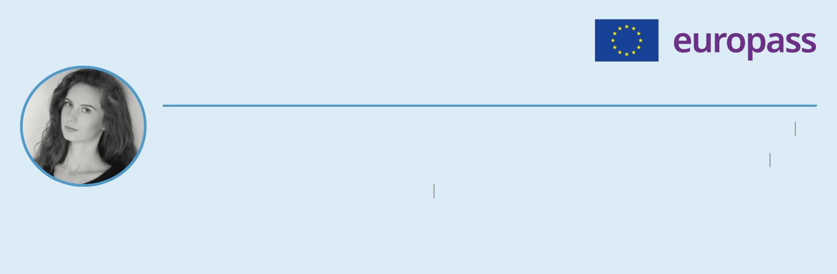**Lucia Gdovin**

**Date of birth**: 07/04/1992  **Nationality**: Slovak 

**Phone number:** (+353) 892187056  **Email address**: [gdovin.lucia@gmail.com](mailto:gdovin.lucia@gmail.com)

**WhatsApp Messenger:** (+353) 892187056   **Instagram:** @liu.vin_

**Address:** 93 Liosmór, Cappagh Road, H91FHF3, Galway, Ireland

**WORK EXPERIENCE**



16/08/2024 – CURRENT Galway, Ireland

**SALES ASSISTANT, DUNNES STORES**



* Customer Service,
* Product Knowledge & Visual Merchandising,
* Cash Handling,
* Hygiene, Health and Safety & Knowledge of HACCP.

30/07/2024 – CURRENT Remote Job

**TRANSCRIBER, PRODUCTIVE PLAYHOUSE, Ins.**



* Typing and Formatting Transcripts,
* Proofreading and Editing Audio/Video Files,
* Confidentiality.

19/09/2019 – 24/06/2024 Bratislava, Slovakia

**SMALL BUSINESS OWNER**



* Entrepreneurial Experience,
* Product Development (Handmade Soy Candles and Wax Melts),
* Customer Service & Inventory Management,
* Creative and Design Skills (e. g. Label Design),
* Marketing and Sales.

01/05/2022 – 31/12/2023 Bratislava, Slovakia

**METHODOLOGIST, THE MONUMENTS BOARD OF THE SLOVAK REPUBLIC**



* Heritage recovery plan (Recovery plan for Europe, European Commission).
* Reformed Decision-Making Processes,
* Cost Calculation Methodology & Specialised Writing,
* Public Outreach & Publication Management,
* Collaborative Teamwork & Professional Engagement.

01/06/2021 – 30/04/2022 Bratislava, Slovakia

**ARCHAEOLOGIST, THE MONUMENTS BOARD OF THE SLOVAK REPUBLIC**



* Enhanced Documentation Accuracy,
* Proposal Development,
* Eﬃcient Project Management.

01/03/2020 – 31/07/2021 Bratislava, Slovakia

**CORPORATE RECEPTIONIST, KKL GROUP s. r. o.**



* Client Experience Enhancement,
* Eﬀective Communication,
* Administrative Operations.

01/01/2019 – 31/08/2019 Bratislava, Slovakia

**ARCHAEOLOGIST, THE MONUMENTS BOARD OF THE SLOVAK REPUBLIC**



* Impact Assessment and Mitigation,
* Expert Advisory Role,
* Protection and Preservation Advocacy.

01/06/2017 – 30/10/2018 Bratislava, Slovakia

**FIELD ARCHAEOLOGIST, ARCHAEOSERVICES s. r. o.**



* Survey and Excavation Leadership,
* Analytical Expertise,
* Comprehensive Reporting.

01/10/2016 – 31/05/2017 Bratislava, Slovakia

**BARISTA, AMREST COFFEE SK s. r. o. (Starbucks)**



* Customer Service Excellence & Product Knowledge and Upselling,
* Team Leadership and Training & Inventory Management,
* Quality Control and Compliance.

01/01/2015 – 31/08/2016 Bratislava, Slovakia

**PART-TIME MANAGER, CITLIMITED s. r. o. (Subway)**



* Operational Eﬃciency & Product Knowledge and Upselling,
* Team Leadership and Training & Inventory Management.
* Quality Control and Compliance.

01/10/2012 – 31/08/2016 Bratislava, Slovakia

**SALES ASSISTANT, CITLIMITED s. r. o. (Subway)**



* Customer Service Excellence,
* Quality Control & Speed and Accuracy,
* Team Collaboration & Training and Mentorship.

01/09/2015 – 30/10/2015 Bratislava, Slovakia

**FRONT DESK RECEPTIONIST, HEINEKEN a. s.**



* Eﬃcient Front Desk Management,
* Administrative Processes and Support,
* Team Collaboration.

01/04/2014 – 31/07/2015 Bratislava, Slovakia

**WAITRESS, MARBEL s. r. o. (Times café)**



* Customer Service Excellence,
* Eﬃcient Table Management,
* Training and Development.

**EDUCATION AND TRAINING**



17/06/2024 – 21/06/2024 Bratislava, Slovakia

**ADOBE ILLUSTRATOR, IT LEARNING SLOVAKIA, s. r. o.**



* Adobe Illustrator I. for beginners (basics and vector graphics),
* Adobe Illustrator II. pre-intermediate (drawing and creative aspects),
* Adobe Illustrator III. (3D and advanced tools).

Field of study: Personal skills and development  Level in EQF EQF level 3

22/05/2024 – CURRENT Bratislava, Slovakia

**WEB DESIGN. BASIC AND ADVANCED HTML & CSS, IT LEARNING SLOVAKIA, s. r. o.**



Field of study: Personal skills and development  Level in EQF EQF level 3

20/05/2024 – CURRENT Bratislava, Slovakia

**ADOBE INDESIGN IT LEARNING SLOVAKIA, s. r. o.**



Field of study: Personal skills and development  Level in EQF EQF level 2

12/02/2024 – 19/02/2024 Bratislava, Slovakia

**ADOBE PHOTOSHOP IT LEARNING SLOVAKIA, s. r. o.**



* Adobe Photoshop I. for beginners (working with the program, graphics, and basic photography skills),
* Adobe Photoshop II. pre-intermediate (working with raster and vector images, basic creative production),
* Adobe Photoshop III. website graphics and marketing (graphics for social media and online advertising).

Field of study: Personal skills and development  Level in EQF EQF level 5

01/09/2017 – 31/08/2023 Prague, Czechia

**POSTGRADUATE DOCTORAL EDUCATION, PREHISTORIC ARCHEOLOGY,**

NOT FINISHED, **Charles University Prague**



Field of study: History and archaeology  Level in EQF EQF level 8

01/09/2022 – 31/01/2023 Galway, Ireland

**ERASMUS+ PROGRAM, POSTGRADUATE DOCTORAL EDUCATION,**

**PREHISTORIC ARCHAEOLOGY University of Galway**



Field of study: History and archaeology  Level in EQF EQF level 8

01/09/2019 – 31/01/2020 Galway, Ireland

**ERASMUS+ PROGRAM, POSTGRADUATE DOCTORAL EDUCATION,**

**PREHISTORIC ARCHAEOLOGY University of Galway**



Field of study: History and archaeology  Level in EQF EQF level 8

01/09/2014 – 31/08/2016 Bratislava, Slovakia

**MASTER'S DEGREE, ARCHAEOLOGY PROGRAM**

**Comenius University in Bratislava, Faculty of Philosophy**



Field of study: History and archaeology  Final grade: Master  Level in EQF EQF level 7

01/09/2011 – 31/08/2014 Bratislava, Slovakia

**BACHELOR'S DEGREE, ARCHAEOLOGY PROGRAM**

**Comenius University in Bratislava, Faculty of Philosophy**



Field of study: History and archaeology  Final grade: Bachelor  Level in EQF EQF level 6

**LANGUAGE SKILLS**



**Mother tongue(s):** SLOVAK | CZECH

**Other language(s): ENGLISH C1** | CHINESE A1

**DIGITAL SKILLS**



Microsoft Oﬃce (Intermediate)  Corel Painter Essential (Proficient)  Adobe Illustrator (Intermediate)  Adobe Photoshop (Advanced)  Corel Draw (Beginner)  Adobe InDesign (Beginner)  Label Design (Advanced)  HTML (Advanced)  CSS (Advanced)  Print Design (Intermediate)

**OTHER SKILLS**



Office Administration  Multitasking  Receptionist Duties  Organisational skills  Time-management  Attention to detail  Creativity  Teamwork  Editing  Proofreading  Candle Making

**HOBBIES AND INTERESTS**



Chinese Language  Japanese Language  Candle Making  Graphic Design  Web Design  Reading  Travelling